“Currency Breakdown Calculator”
A Project Report Submitted in the partial fulfillment of the requirements of the course titled
“Problem Solving Through Programming (JAVA)”

BACHELOR OF TECHNOLOGY
In DEPARTMENT OF FRESHMAN ENGINEERING by
Name | Roll Number
K. Satwik | 2520030446
B. Harshitha | 2520080007
V. Rohan | 2520030558
B. Niharika | 2520030589
M. Shravya | 2520030588
K. Anshu | 2520030440

Under the Esteemed Guidance of
Dr. Venkat Isampalli Sir



Koneru Lakshmaiah Education Foundation
(Category-I, Deemed to be University, estd. u/s 3 of the UGC Act, 1956)
ALEAP Industrial Area, Gajularamaram, Bachupally,
Hyderabad, Telangana 500090
K L (Deemed to be) University
Depart of Freshman Engineering



DECLARATION

The Project Report entitled “Simple Banking System” is a record of Bonafide work of K. Satwik - 2520030446, B. Harshitha - 2520080007, V. Rohan - 2520030558, B. Niharika - 2520030589, M. Shravya - 2520030588, K. Anshu – 2520030440 submitted in partial fulfillment of the requirements of the course titled “Problem Solving Through Programming (JAVA)” under the B.Tech Ist Year Trimester – I program in Department of Freshman Engineering at K L University. The results presented in this report have not been copied from any other department, university, or institute.

K. Satwik – 2520030446
B. Harshitha – 2520080007
V. Rohan – 2520030558
B. Niharika – 2520030589
M. Shravya – 2520030588
K. Anshu- 2520030440

K L (Deemed to be) University
Depart of Freshman Engineering



CERTIFICATE

This is certify that the java project based report entitled “Currency Breakdown Calculator” is a bonafide work done and submitted by K. Satwik - 2520030446, B. Harshitha - 2520080007, V. Rohan - 2520030558, B. Niharika - 2520030589, M. Shravya - 2520030588, K. Anshu – 2520030440 in partial fulfillment of the requirements of the course titled “Problem Solving Through Programming (JAVA)” under the B.Tech Ist Year Trimester - I program in Department of Freshman Engineering, K L (Deemed to be University), during the academic year 2025-2026.

Signature of the Course Coordinator | Signature of the Guide | Signature of the HOD
ACKNOWLEDGEMENT

The success in this project would not have been possible but for the timely help and guidance rendered by many people. Our wish is to express our sincere thanks to all those who have assisted us in one way or the other for the completion of this project.

Our greatest appreciation goes to our Course Coordinator, Dr Y. Ashok, and our guide, Dr. Venkat Isampalli, Department of Freshman Engineering, which cannot be expressed in words for their tremendous support, encouragement and guidance for this project.

We express our gratitude to Dr. N. Chaitanya Kumar, Head of the Department for Freshman Engineering for providing us with adequate facilities, ways and means by which we are able to complete this project-based Lab.

We thank all the members of teaching and non-teaching staff members, and also who have assisted us directly or indirectly for successful completion of this project. Finally, we sincerely thank our parents, friends and classmates for their kind help and cooperation during this work.

Abstract

The Currency Breakdown Calculator is a simple program that helps to find out how many notes of each denomination are needed for a given amount of money. The user enters an amount, and the program calculates the number of notes for each value, such as 100s, 50s, 20s, 10s, etc.

This project helps in understanding basic programming concepts like division, loops, and conditional statements. It also improves logical thinking and problem-solving skills. The calculator can be easily changed to work with different countries’ currencies by updating the denominations.

Index

S. No. | Chapters | Topics | Page no.
 |  | Acknowledgement | 4
 |  | Abstract | 5
1 | Introduction | - – Background of the Project  1.2 – Problem Statement | 7
2 | System Architecture | - - High-Level Architecture  Diagram/Block Diagram  2.2 - Class Diagram | 8
3 | CO’s Attainments | 3.1 – CO1 Attainment  3.2 – CO2 Attainment  3.3 – CO3 Attainment  3.4 – CO4 Attainment  3.5 – CO5 Attainment  3.6 – CO6 Attainment | 9 - 14
4 | Screenshots | 4.1 – Screenshots | 15 - 16
5 | Testing | 5.1 – Test Cases & Results | 17 – 21
6 | Future Enhancements | 6.1 – Planned Features  6.2 – Possible Integrations or Optimizations | 22
7 | Conclusion | 7.1 – Summary of the Project  7.2 – What We Achieved  7.3 – Skills We Learned During Development | 23
8 | References | Books, tutorials, documentation sites used | 24
9 | Appendices | Installation/ Setup Instructions  User Manual/ Guide  Geo-Tag Photos with Guide  Review Forms with Guide’s Signature | 25 - 26

CHAPTER 1- INTRODUCTION

  - – Background of the Project

The Currency Breakdown Calculator is a precise software utility engineered to decompose a total cash amount into a clear, structured distribution of currency notes. In many real-world scenarios, individuals and businesses need an immediate understanding of how a given sum translates into physical denominations, particularly when preparing payments, organizing cash drawers, or verifying cash totals.

Performing this task manually becomes increasingly inefficient as amounts grow larger or when multiple denominations are involved, often leading to calculation mistakes or slowed workflows. This tool simplifies the process by delivering a denomination-wise summary instantly and accurately.

The calculator evaluates commonly used note values such as 200, 100, 50, 20, 10, and smaller units and generates a breakdown that ensures the original amount is preserved in full.

By logically mapping the input amount to note quantities, the program offers practical value in time-critical circumstances, including billing, cash reconciliation, and offline financial planning where physical currency is prioritized.

The design supports direct modification of denominations, enabling compatibility with various national currency systems without altering the core logic. Its simplicity allows users to operate the system with minimal steps, while its underlying logic ensures predictable, repeatable, and mathematically sound outputs for every valid input.

This project reflects an essential intersection of utility and computation, demonstrating how even routine financial tasks can benefit from automation that emphasizes accuracy, clarity, and adaptability.

  - – Problem Statement

In the development of this project, we recognized that the need to translate a total cash value into its currency notes is a universally encountered task in financial transactions. Although the arithmetic involved is simple, the process becomes highly repetitive when applied frequently, inefficient when dealing with large numbers, and prone to human error when multiple denominations must be considered simultaneously. Manual note breakdown requires sequential division, subtraction, and verification, a method that lacks standardization, consumes time, and forces repeated recalculation even for routine amounts.

As a team, we experienced this as a practical shortcoming: while digital payment systems offer extensive automation, structured tools dedicated specifically to physical currency analysis and note-level decomposition are limited. This highlighted the core problem we aimed to solve: creating an automated system that accepts a numerical cash total and reliably converts it into a systematic, denomination-wise note breakdown while maintaining mathematical integrity and operational efficiency.

CHAPTER 2- SYSTEM ARCHITECTURE

  - – High Level Architecture Diagram

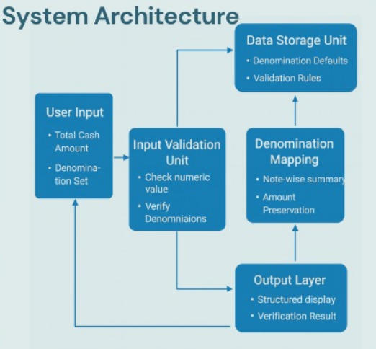

  - – Class Diagram

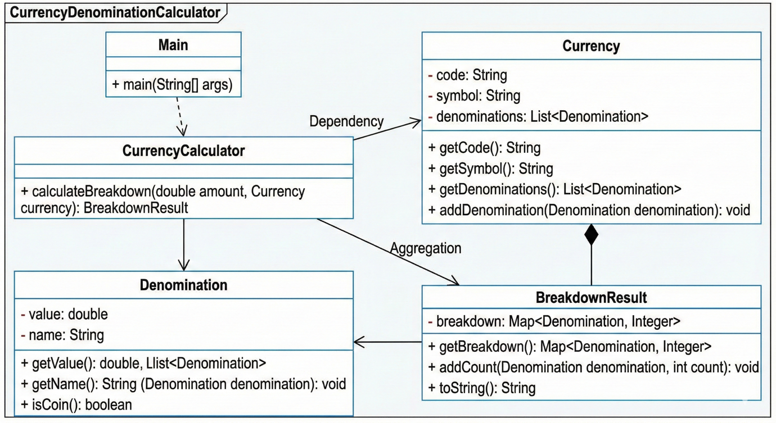

CHAPTER 3- CO’S ATTAINMENTS

3.1 – CO1 Attainment

CO1 Syllabus | CO1 Concepts incorporated into the project
Apply fundamental programming constructs such as data types, operators, conditional and iterative statements in Java to develop logic-based solutions for basic computational problems. Students will learn to design simple algorithms, trace execution, and validate logic through hands-on coding tasks. | The project utilizes the Scanner class to handle user input and primitive data types (example - int) to store the monetary amount and denomination counts. It implements fundamental arithmetic operators, specifically integer division (/) to determine the count of notes and modulus (%) to calculate the remaining balance, creating a sequential logic flow to solve the computational problem of currency breakdown.

3.1.1 – Scenarios for CO1’s Implementation

The scenario addresses a basic computational problem where a user needs to break down a specific amount of money into the minimum number of currency notes. The program accepts an integer input representing the total amount (e.g., 2500) and uses a logic-based solution to calculate how many notes of 500, 200, 100, 50, 20, and 10 are required. This validates the student's ability to trace execution flow and apply mathematical operators in a programming context.

3.1.2 – Screenshot of CO1 segment from code

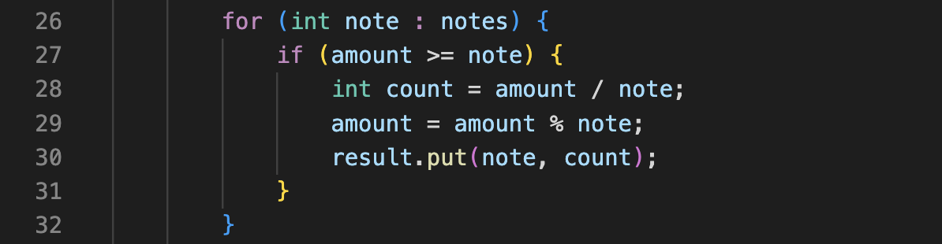

3.2 – CO2 Attainment

CO2 Syllabus | CO2 Concepts incorporated into the project
Design, trace, and optimize algorithms using one-dimensional and two-dimensional structures to solve computational problems, and analyze efficiency and accuracy of algorithmic approaches. | The system uses a one-dimensional integer array (int[]) within the INR class to store all valid currency denominations (e.g., {500, 200, 100...}). The breakdown calculator method then iterates through this array using an enhanced for loop to systematically perform the division and modulus operations, providing an optimized and structured algorithm.

3.2.1 – Scenarios for CO2’s Implementation

The calculation logic is optimized by retrieving the denominations via the currency.getDenominations() method, which returns the array. A loop (for (int note : notes)) iterates over this array, reducing code redundancy and allowing the algorithm to efficiently process any set of denominations defined in the Currency classes.

3.2.2 – Screenshot of CO2 segment from code

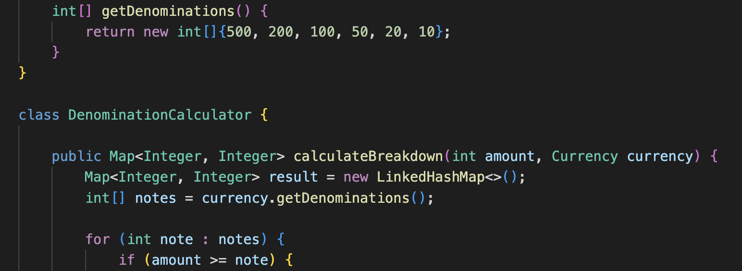

3.3 – CO3 Attainment

CO3 Syllabus | CO3 Concepts incorporated into the project
Construct and evaluate advanced problem-solving logic using strings, recursion, and bitwise operations for solving computational problems relevant to coding platforms. Students will integrate mathematical reasoning and pattern recognition into coding strategies. | This method employs advanced String handling using the StringBuilder class to efficiently operate the breakdown results into a final receipt format. It also uses String.format() for precise alignment and presentation of the currency symbol, value, and note count in the output.

3.3.1 – Scenarios for CO3’s Implementation

After the calculation is complete, this method takes the resulting Map and uses StringBuilder to construct a clean, formatted receipt. This ensures that the program output is robustly structured and easily readable, fulfilling the requirement for applying advanced string concepts.

3.3.2 – Screenshot of CO3 segment from code

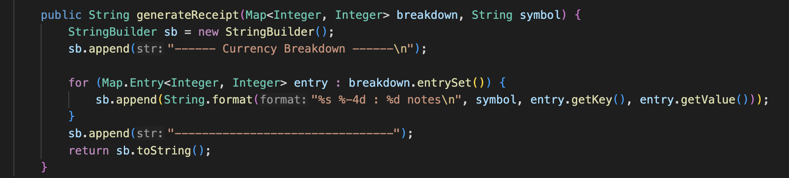

3.4 – CO4 Attainment

CO4 Syllabus | CO4 Concepts incorporated into the project
Develop structured and modular programs by applying object-oriented programming principles such as encapsulation, abstraction, and modularization using Java classes, methods, and constructors. Students will transition from procedural to modular design thinking. | The project is structured using three distinct classes (CurrencyProject, Currency, DenominationCalculator) to achieve modularization. The DenominationCalculator class encapsulates the core business logic in methods like calculateBreakdown() and generateReceipt(), separating the logic from the user interface (main method).

3.4.1 – Scenarios for CO4’s Implementation

The main method acts only as the driver, demonstrating modularization by creating objects (new DenominationCalculator()) and calling their methods. The calculator methods themselves demonstrate encapsulation by only exposing necessary functionality (the public calculation method) while hiding the internal logic.

3.4.2 – Screenshot of CO4 segment from code

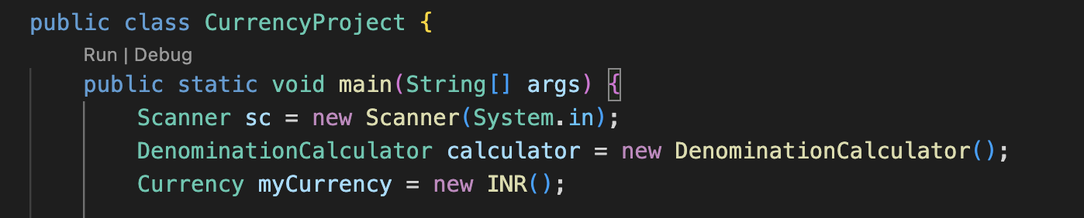

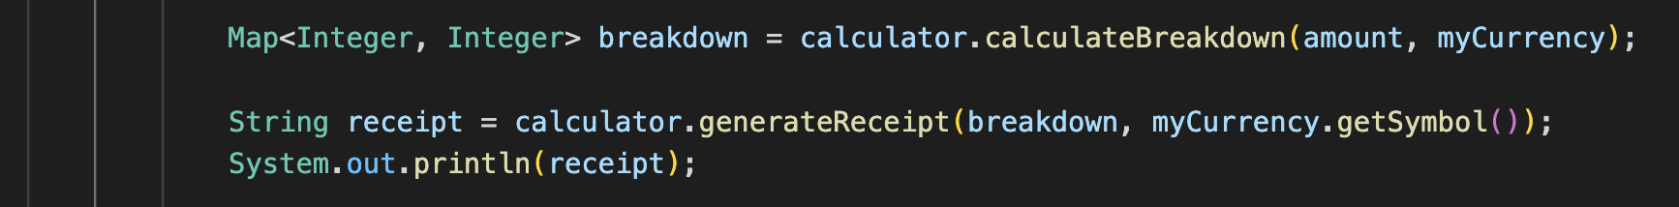

3.5 – CO5 Attainment

CO5 Syllabus | CO5 Concepts incorporated into the project
Implement robust Java applications using exception handling, error validation, and appropriate debugging techniques to ensure secure and reliable program execution. Students will understand how to anticipate, detect, and handle runtime issues. | The project uses Inheritance by defining an abstract class Currency which is then extended by the concrete class INR. The abstract methods (getSymbol, getDenominations) ensure abstraction, while the ability of the calculator to accept any object extending Currency demonstrates Polymorphism and code reusability.

3.5.1 – Scenarios for CO5’s Implementation

By using an abstract class and inheritance, the system is extensible. The DenominationCalculator method signature is calculateBreakdown(int amount, Currency currency), making it accept any type of currency (INR, USD, etc.) that inherits from the abstract Currency class, allowing for different denomination rules without changing the core calculation logic.

3.5.2 – Screenshot of CO5 segment from code

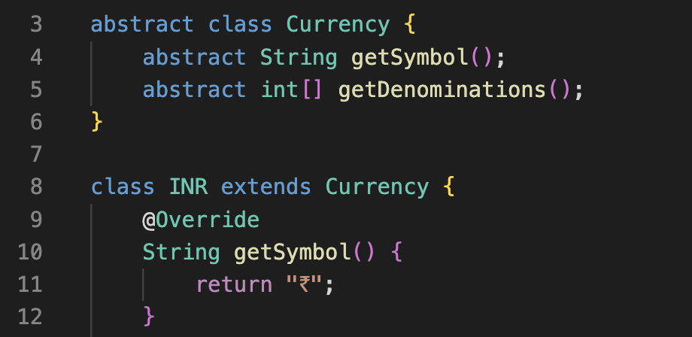

3.6 – CO6 Attainment

CO6 Syllabus | CO6 Concepts incorporated into the project
Implement robust, scalable, and generic Java applications integrating exception handling, file I/O, generics, and collections framework. | The program ensures robustness by integrating Exception Handling (try-catch blocks) to manage user input errors (specifically InputMismatchException). It uses the Collections Framework by employing a Map<Integer, Integer> (LinkedHashMap) with Generics to store and manage the final currency breakdown data.

3.6.1 – Scenarios for CO6’s Implementation

The calculation results are stored in a Map (a Collection) where the key is the denomination value and the value is the note count. This is more dynamic than using fixed variables. Furthermore, the try-catch block around sc.nextInt() prevents the application from crashing if the user enters text instead of a number.

3.6.2 – Screenshot of CO6 segment from code

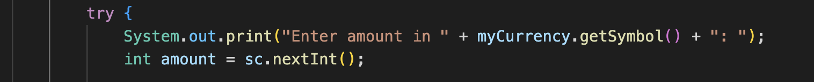

CHAPTER 4- SCREENSHOTS

4.1 – Screenshots

Screenshot of project with example test case-

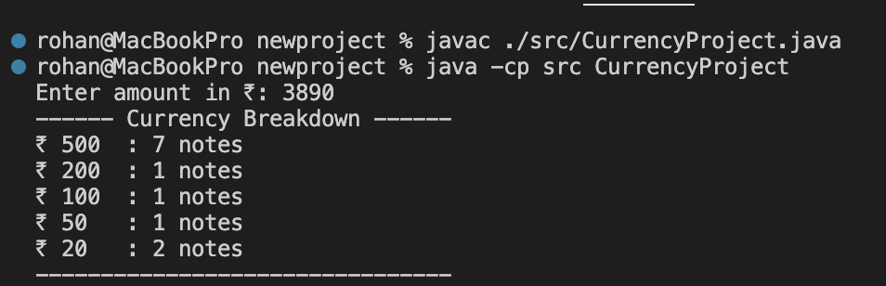

Raw code written in Visual Studio Code-

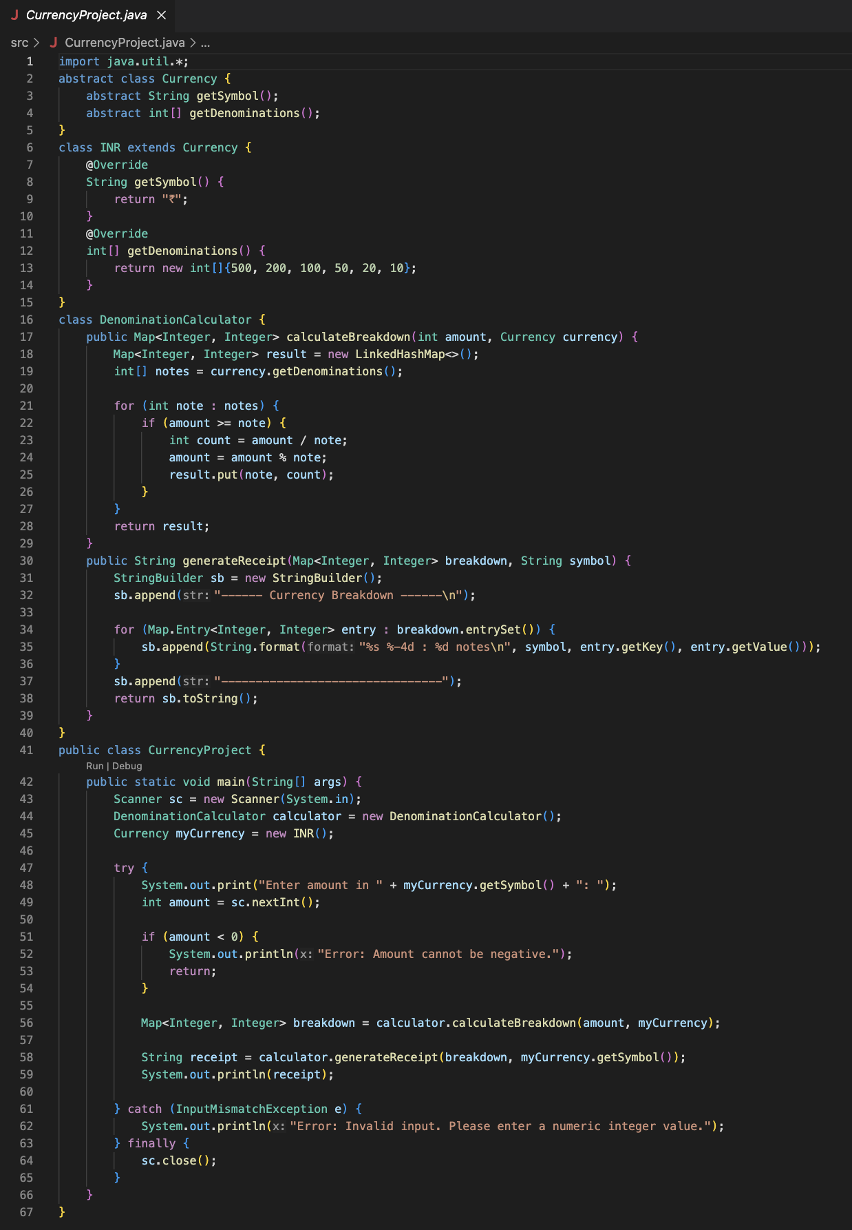

CHAPTER 5- TESTING

5.1 – Test Cases & Results

- Full Breakdown

Input amount-

₹ 3890;

Expected output-

₹ 500 : 7 notes, ₹ 200 : 1 notes, ₹ 100 : 1 notes, ₹50 : 1 notes, ₹ 20 : 2 notes

Actual output-



- Zero Remainder

Input amount-

₹ 1000;

Expected output-

₹ 500 : 2 notes

Actual output-

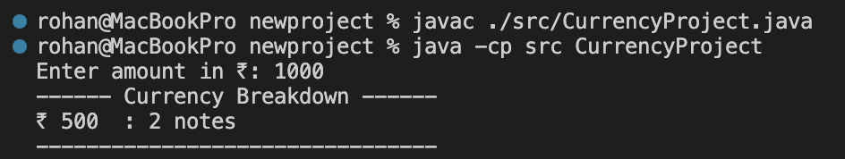

- Unaccounted Remainder

Input amount-

₹ 333;

Expected output-

₹ 200 : 1 notes, ₹ 100 : 1 notes, ₹ 20 : 2 notes, ₹ 10 : 1 notes
Unaccounted balance : ₹ 3

Actual output-

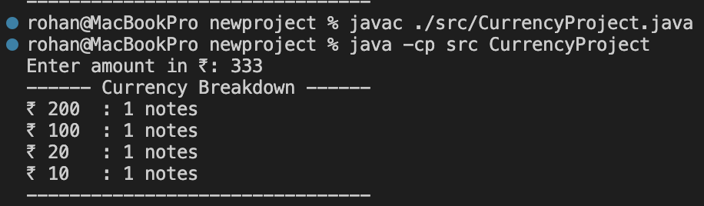

- Edge case (invalid input)

Input amount-

ABC;

Expected output-

Error: Invalid input. Please enter a numeric integer value.

Actual output-

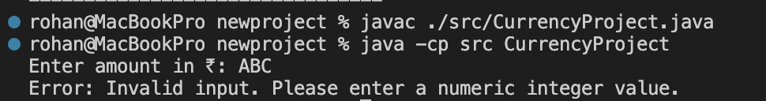

- Edge case (amount zero)

Input amount-

₹ 0;

Expected output-

No breakdown is required/ possible.

Actual output-

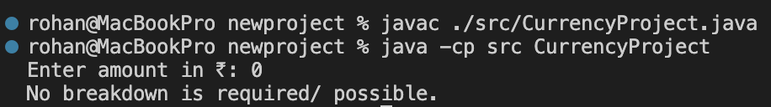

CHAPTER 6- FUTURE ENHANCEMENTS

  - – Planned Features

- Implement a Currency Factory Design Pattern:

- Goal: Introduce a dedicated CurrencyFactory class responsible for creating concrete currency objects (like INR or future USD classes) based on a runtime parameter.

- Benefit: This fully decouples the main calculator logic from object creation, significantly improving the design's adherence to professional software architecture principles and enhancing system scalability.

- Audit Logging:

- Goal: Implement a simple logging mechanism to record every calculation request, including the input amount, timestamp, and final breakdown result.

- Benefit: Ensures fault tolerance and provides a history for debugging and auditing purposes (related to CO6).

  - - Possible Integrations or Optimizations

- Migration to a Desktop GUI (JavaFX/Swing):
- Integration: Implement a full desktop Graphical User Interface (GUI) using JavaFX.

- Benefit: Provides a professional, native look-and-feel that replaces the console or web-based interface, offering a richer user experience with live input validation and visually appealing results.
- Performance Optimization for Large Calculations:
- Optimization: For extremely large calculations (e.g., breaking down billions), introduce more in-depth and complex techniques to ensure calculation speed remains fast, even under heavy load.

CHAPTER 7- CONCLUSION

7.1 - Summary of the Project

The project is a Currency Breakdown Calculator we developed using Java. The application's core function is to receive a total amount as input and determine the minimum number of notes required for a specific set of denominations (₹500, ₹200, ₹100, ₹50, ₹20, and ₹10). The final product features a strong separation of concerns, ensuring high code reusability and extensibility.

7.2 - What Was Achieved

- Modularity: Modularization was achieved by separating the logic into dedicated classes (DenominationCalculator, Currency). This structure was enhanced using Inheritance and Abstraction via the abstract class Currency, allowing the system to handle any currency type via polmorphism.

- Scalability: The application integrates Collection Frameworks to store breakdown results and employs robust Exception Handling to prevent crashes from invalid user input.

7.3 - Skills Learned During Development

- Core Java Fundamentals: Mastery of control structures, data types (int), and fundamental arithmetic operations (division and modulus).

- OOP Principles: Practical application of Encapsulation, Inheritance, and Polymorphism to design modular and extensible code.

- Data Structures and Robustness: Effective use of the Collections Framework for dynamic data storage and implementation of defensive programming via Exception Handling.

- Code Optimization: Using arrays and iterative loops to replace redundant code, leading to cleaner and more maintainable algorithms.

CHAPTER 8- REFERENCES

Books

- Pressman, R. S., & Maxim, B. R. (2019). Software Engineering: A Practitioner’s Approach (8th ed.). McGraw-Hill Education.

- Schildt, H. (2019). Java: The Complete Reference. McGraw-Hill Education.

- Budd, T. (2002). Understanding Object-Oriented Programming with Java. Addison-Wesley.

- Sommerville, I. (2016). Software Engineering (10th ed.). Pearson Education.

- Deitel, P. & Deitel, H. (2017). Java How to Program. Prentice Hall.

Tutorials and Learning Resources

  - GeeksforGeeks
Retrieved from: https://www.geeksforgeeks.org/java/

  - TutorialsPoint
Retrieved from: https://www.tutorialspoint.com/java/

  - ChatGPT
Retrieved from: https://chatgpt.com/

  - Google Gemini
Retrieved from: https://gemini.google.com/app

APIs and Tools Used

  - Java Development Kit (JDK)
JDK (2025) used for compiling, running, and testing the Simple Banking System program.
Retrieved from:
https://www.oracle.com/java/technologies/javase-downloads.html

  - IDE Used (VS Code)
Integrated Development Environment used for coding, debugging, and testing.
Retrieved from:
https://code.visualstudio.com/

  - GitHub
Used for version control, code backup, and uploading finished project.
Retrieved from: https://github.com/

CHAPTER 9- APPENDICES

Installation steps for tools used

Visual Studio Code (VS Code)

- Go to https://code.visualstudio.com
- Download VS Code for your operating system
- Run the installer and follow default steps
- Launch VS Code after installation

Java Development Kit (JDK)

- Go to https://www.oracle.com/java/technologies/downloads/
- Download the latest JDK
- Run the installer
- Verify installation:
Type “java -version” in terminal

VS Code Java Setup

- Open VS Code
- Go to Extensions (Ctrl+Shift+X)
- Install Extension Pack for Java
- Restart VS Code

User Manual / Guide

Steps for running the program

- Open the project folder in VS Code

- Open Terminal in VS Code

- Compile the program:

Type “javac ./src/CurrencyProject.java”

- Run the program:

- Type “java CurrencyProject”

- Enter the amount when prompted

- View the currency breakdown output in the terminal

Geo-Tag photos

